**8. Check iwconfig/ifconfig to understand in detail about network interfaces (check about Interface speed, MTU and other parameters)**

**8.a. ifconfig:**

The ifconfig command manages network interface parameters.

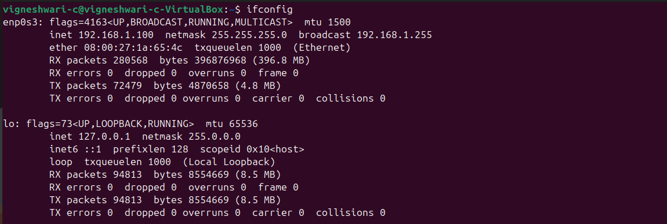

PARAMETERS OF IFCONFIG:

• **Flags:** Interface status -UP, LOOPBACK, RUNNING

• **MTU**(Maximum Transmission Unit) -65536 bytes

• **IPv4 Address** (inet)-Localhost IP address-127.0.0.1

• **Subnet Mask** (netmask)-Defines the network range-255.0.0.0

• **IPv6 Address** (inet6) IPv6 localhost ::1

• **RX Packets**-Received packets count-94729

• **RX Bytes**-Total data received-8.5 MB

• **TX Packets**-Transmitted packets count-94729

• **TX Bytes**-Total data sent-8.5 MB

• **Errors, Drops, Overruns, Collisions** (RX errors, TX errors, dropped, overruns, collisions) – 0 errors.

**8.b. iwconfig:**

The iwconfig command configures a wireless network interface. It is used to set the parameters of the network interface that are specific to the wireless operation.

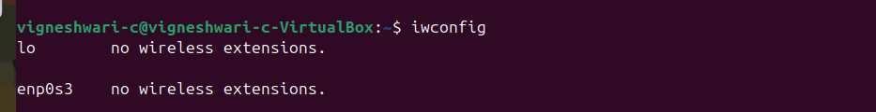

PARAMETERS OF IWCONFIG:

* **essid** : Set the ESSID (or Network Name - in some products, it may also be called Domain ID).
* **nwid** : Set the Network ID.
* **nick :** Set the nickname, or the station name.
* **mode**:Set the operating mode of the device, which depends on the network topology.
* **freq/channel**: Set the operating frequency or channel in the device.
* **rate**/**bit:** To set the bit rate in b/s.
* **sens:**To set the sensitivity threshold**.**
* **key/enc**:Used to manipulate encryption or scrambling keys and security mode.
* **rts:**RTS/CTS adds a handshake before each packet transmission to make sure the channel is clear.